**Software Requirements Specification**

**for**

SkillShow

**Version 1.0 approved**

**Prepared by,**

**Team Dingo**

**COS420Fall2025**

**9/29/2025**

**Table of Contents**

**Table of Contents ii**

**Revision History ii**

**1. Introduction 1**

1.1 Purpose 1

1.2 Document Conventions 1

1.3 Intended Audience and Reading Suggestions 1

1.4 Product Scope 1

1.5 References 1

**2. Overall Description 2**

2.1 Product Perspective 2

2.2 Product Functions 2

2.3 User Classes and Characteristics 2

2.4 Operating Environment 2

**3. External Interface Requirements 3**

3.1 User Interfaces 3

**4. System Features 4**

4.1 System Feature 1 4

4.2 System Feature 2 (and so on) 4

**5. Other Nonfunctional Requirements 4**

5.1 Performance Requirements 4

5.2 Safety Requirements 5

5.3 Security Requirements 5

5.4 Software Quality Attributes 5

5.5 Business Rules 5

**6. Other Requirements 5**

**Appendix A: Glossary 5**

**Appendix B: Analysis Models 5**

**Appendix C: To Be Determined List 6**

**Revision History**

| **Name** | **Date** | **Reason For Changes** | **Version** |
| --- | --- | --- | --- |
| Mason Peasley | 10/20/25 | Revising Requirements | 0.0.1 |
| Mason Peasley | 10/21/25 | Deliverable 2 (Start) | 0.0.2 |
| Mason Peasley | 10/24/25 | Finished Deliverable 2 version | 0.0.3 |
|  |  |  |  |

# **Introduction**

## **Purpose**

SkillShow is a digital portfolio platform that aims to help computer science students and graduates showcase their skills and connect with potential employers. SkillShow will allow for integration with users’ GitHub repositories to provide a more organized and customizable overview of their work. Users will be able to highlight specific projects, technical skills, and specialized areas such as AI proficiency, allowing them to create a portfolio that will showcase both their current strengths and future career goals.

## **Document Conventions**

This Document was created based on the IEEE template for System Requirement

Specification Documents.

## **Intended Audience and Reading Suggestions**

This document is for developers, project managers, users, and testers.

## **Product Scope**

The Software will be a Backend as a service (Baas, a NoSQL database program). We are specifically using Firebase to create the application. Its purpose is to act as a professional portfolio viewer for individuals seeking employment in computer science and related fields. The software promotes the corporate goal of loyal customers. The hiring atmosphere for coding jobs is becoming more and more difficult. Job seekers in this atmosphere are looking for any edge to put them above their peers. This will create loyal customers.

## **References**

*Team D GitHub Link:* [*https://github.com/COS420-F25/TeamD*](https://github.com/COS420-F25/TeamD)

# **Overall Description**

## **Product Perspective**

SkillShow is being developed for everybody that wants to showcase their coding portfolio. More specifically, it is aimed towards individuals that want their work seen by potential employers. SkillShow will also link with the user’s GitHub account so that their repositories may be displayed on their portfolio. There will also be a section for employers to find candidates. It is a new product being created with open-source code.

## **Product Functions**

Account Creation

* Input Username: Allows the user to put in a username to log in.
* Input Password: Allows the user to put in a password to log in.

Filtering Profiles

* Select Tags: Filters list of portfolios by tags so only portfolios with selected tags are displayed.
* Sort by Distance: Filter candidates by selected mile range from user.

Link GitHub

* Link GitHub: Allows the user to link their GitHub account to display repositories.
* UnLink GitHub: Allows the user to unlink their GitHub account.

Customize Portfolio

* Select Layout: Allows the user to select a list or grid view for their portfolio.
* Select Theme: Allows the user to select from preset themes for their portfolio.
* Upload Media: Allows users to upload profile pictures and resumes.
* Add Tags: Allows users to add relevant tags to their profile for filtering.

## **User Classes and Characteristics**

The software is created for three user classes, each with different functionalities.

Portfolio creators form the core user base of this software. They are given many features including: profile creation and accessing the same, portfolio creation and management, GitHub account linking and repository display capabilities. They also are given the capability to endorse others' portfolios and leave feedback. They will have standard user access with permissions limited to personal content creation, editing, and community interactions.

Employers primarily act as viewers and communicators within the system. Their goal is to identify and connect with qualified candidates based on displayed portfolios and tagged skills. They are able to view users' portfolios, contact users through email, and filter for candidates using tags.

Developers are responsible for the maintenance, security, and overall performance of the platform. They have superior security clearances compared to the previous two user classes. They can use this to modify the content of the website and access critical information. These privileges enable them to keep the platform up-to-date and secure.

## **Operating Environment**

SkillShow is created using the React App, with HTML, CSS, and TypeScript. As long as the user is not blocking HTML, they will be able to use our application.

# **External Interface Requirements**

## **User Interfaces**

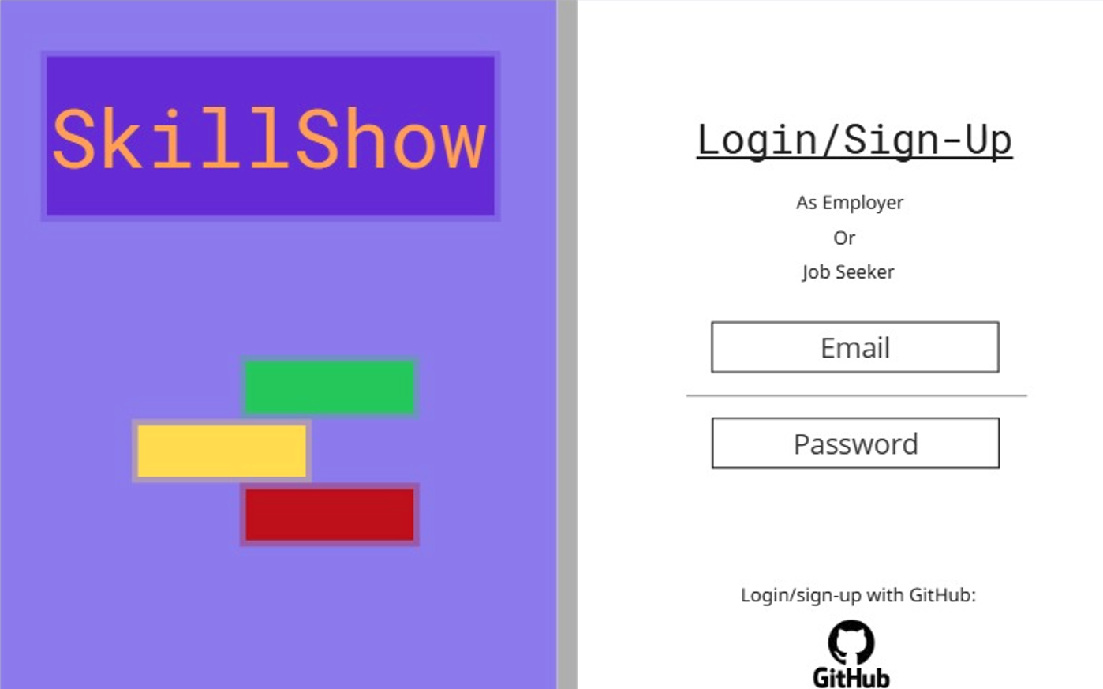

**This is an example of the SkillShow home screen. On the right side of the page you can login/Sign-Up with your email and password. You can either choose to be an Employer or Job Seeker when signing up. You can also sign in using your GitHub account at the bottom by clicking the GitHub icon which is an option.**

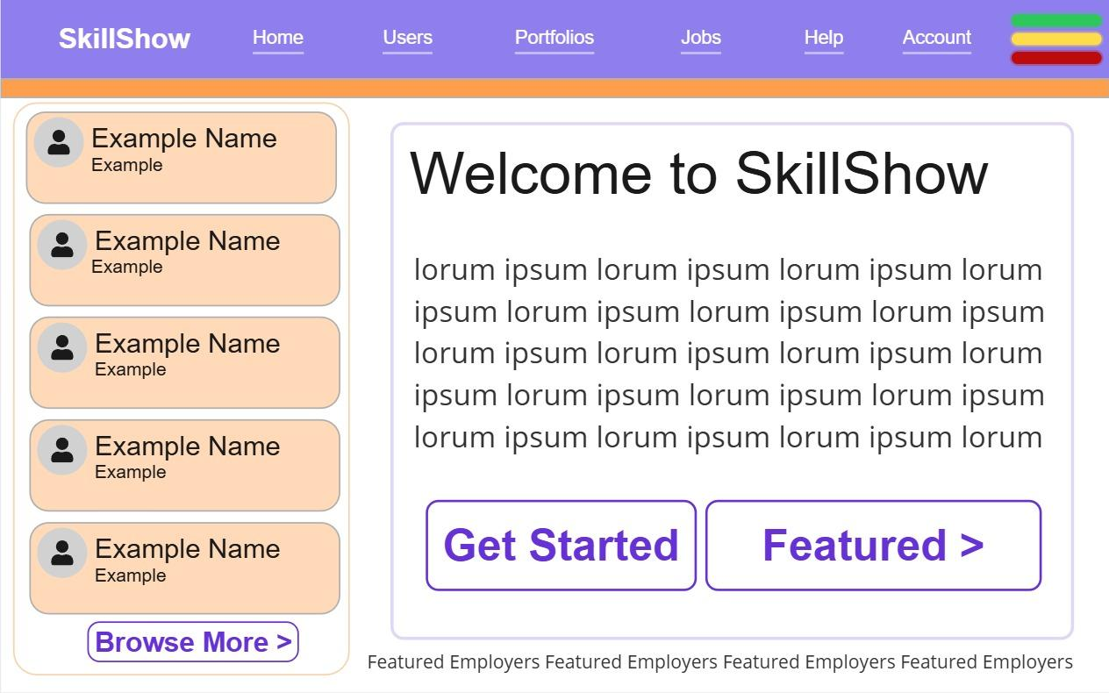

**This is what will be seen after logging in, at the top right is the account where you can edit details of your account. Top right with the three green, yellow, and red colored lines is the settings. On the left some featured jobs or job seekers will be displayed, with the browse more button bringing you to the search. The get started button will bring you to the account settings page where you can edit or create a profile and setup your profile. Featured brings you to a page showing off curated or popular profiles.**

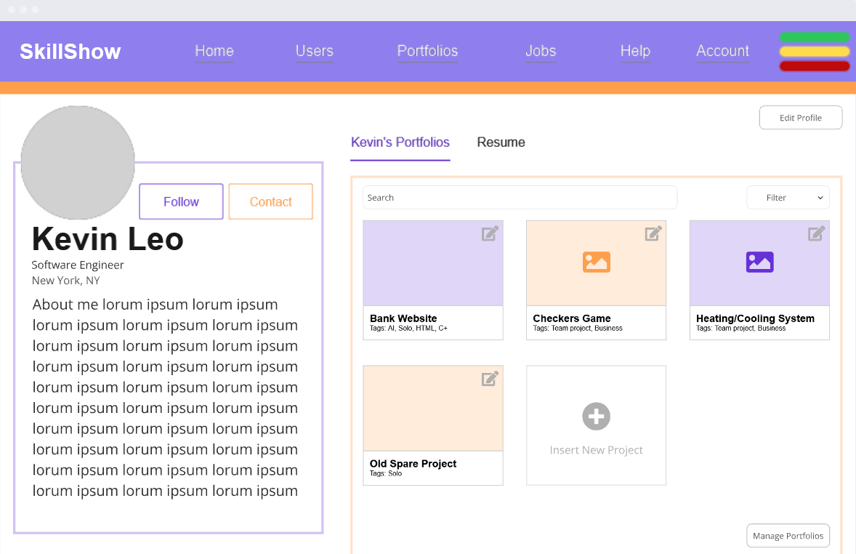

**When you click on one of the visual options while browsing through the options, you can see the individual’s account. There you can see a project listing of what they have done and details about it, an “About Me” they can edit that includes information about themselves and how to contact them. Also personal information at the far right under their profile picture.**

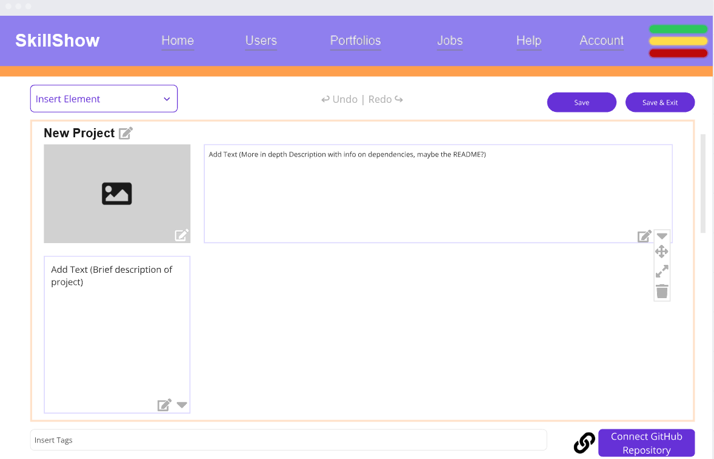

**This gives an overview of a New Project being created by the individual. The individual has options such as naming the project, editing the cover image, adding a description text area for files, more text, or an README. User can undo and redo when editing and also save that way they don’t have to post it, but it is ready to continue being edited anytime. At the bottom tags can be inserted for specifics of the project, and you can copy link or connect GitHub Repository for transferring files. At the top left the ability to insert elements is also available.**

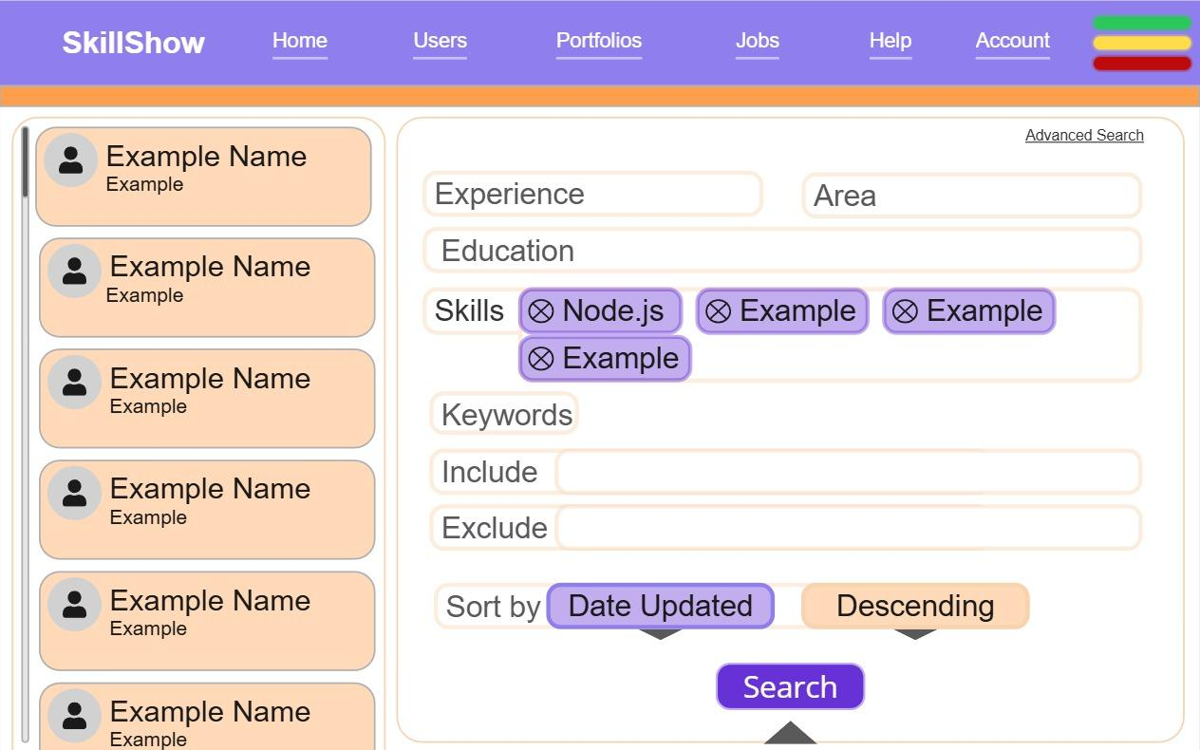

**This is what employers see on the search page for job-seekers. Profiles are on the left, and the search function is on the right. You click in the boxes to add filters such as area, years of experience, education, skills, excluding or including certain keywords, and how the results are sorted.**

# **System Features**

## Personal Profile Creation and Customization

4.1.1 Description and Priority (High Priority)

This feature enables users to create, personalize, and manage their personal profiles within the platform. Users can input personal details (e.g., name, bio, location), upload a profile picture or resume, and showcase their professional portfolio. They can also customize the visual layout and theme of their portfolio to reflect their personal branding preferences.

4.1.2 Stimulus/Response Sequences

When a user chooses to create a profile, the system displays a blank form for inputting personal details such as name, bio, and location, along with options to upload a profile picture or resume. After the user enters their information and saves it, the system validates the data, stores it, and confirms successful creation.

When customizing their portfolio, users can select a preferred layout (grid or list) and one of five preset themes; the system immediately updates the portfolio preview to reflect these choices. If an employer contacts a user through the platform, the system sends an email notification.

4.1.3 Functional Requirements

REQ-1A: The system must allow users to create, update, and delete their personal accounts.

REQ-1B:The system must allow users to update their profile information including name, bio, location, and profile picture.

REQ-2: The system must allow users to log in with a valid username and password.

REQ-3: The system must allow users to submit public written feedback on other users’ portfolios via a comment section

REQ-4: The system must allow users to set privacy permissions for their portfolio by toggling the comment section between public and private.

REQ-5: The system shall send an email notification to a user when an employer contacts them through the platform after viewing their portfolio.

REQ-6A: The system must allow users to customize the layout of their portfolio by selecting a “grid” or “list” layout.

REQ-6B:The system must allow users to customize the theme of their portfolio by selecting from 5 preset themes.

REQ-7: The system shall display the number of profile views, unique visitors, and endorsements from other users.

REQ-8: The system must allow users to tag projects with relevant skills.

REQ-9: The system must support uploading and displaying additional media such as resumes and profile pictures.

REQ-10: The system shall allow users to preview their portfolio before publishing live.

## Github Repository Integration

* + 1. Description and Priority (Medium Priority)

This feature enables seamless integration between our platform and GitHub repositories. Users will be able to connect their GitHub accounts, import repositories, view commits, track code changes, and automatically synchronize updates.

4.1.2 Stimulus/Response Sequences

When a user chooses to connect their GitHub account, the system redirects them to GitHub’s authorization page to grant access permissions. Once authorization is confirmed, the system retrieves and displays a list of the user’s repositories, allowing them to select which ones to showcase in their portfolio. After selection, the system imports repository data—including names, descriptions, commit history, contributors, and update timestamps—and displays them on the user’s portfolio page. Users can also reorder repositories using drag-and-drop functionality or by setting a manual priority, with changes saved automatically. If the user unlinks their GitHub account, the system removes all associated repositories from the portfolio and confirms successful disconnection.

4.1.3 Functional Requirements

REQ-11: The system shall allow users to connect their GitHub account and display selected repositories on their portfolio.

REQ-12: The system shall allow users to include direct links in their portfolio to their displayed repositories in GitHub

REQ-13: The system shall allow users to add a markdown-formatted overview for each connected repository

REQ-14: The system shall allow users to tag their repositories with relevant metadata such as skills, software, or languages used.

REQ-15: The system shall allow users to display repository statistics including commit history, contributor count, and last update date.

REQ-16: The system shall allow users to customize the display order of their repositories by using drag-and-drop functionality or a manual prioritysetting.

REQ-17: The system shall allow users to unlink their GitHub account and remove repositories.

* 1. **Account Filtering and Searching**
     1. Description and Priority (Low Priority)

This feature allows users to efficiently locate and manage accounts by applying advanced filtering and search capabilities. Users can search accounts by name, email, status, role, creation date, and other customizable attributes.

4.1.2 Stimulus/Response Sequences

When a user accesses the account search interface, the system displays available filtering and search options such as name, email, and creation date. Employers can apply filters to narrow results to candidates who are marked as “Looking” for jobs, have logged in within the last 30 days, or match specific skill tags. Once filters or search criteria are submitted, the system processes the input and displays a list of matching accounts ranked by relevance. When a candidate’s profile is opened, the system prominently displays their job-seeking status. Users who have set their status to “Not Looking” are automatically excluded from employer searches.

4.1.3 Functional Requirements

REQ-18: The system shall allow for users to set their job-seeking status between “Looking” and “Not Looking” on their profile page.

REQ-19: The system shall not display users who have marked they are “Not Looking” to employers looking through candidates

REQ-20: The system shall display a user's job seeking status prominently on their profile.

REQ-21: The system shall provide employers with a filter for users marked “Looking” during a search for candidates

REQ-22: The system shall provide a search filter for candidates who have logged in within the last 30 days.

REQ-23: The system shall allow employers to search for candidates by selecting tags and return the best matching candidates, ordered by relevance based on the number and specificity of matching tags.

# **Other Nonfunctional Requirements**

## **Performance Requirements**

REQ-24: The system shall load any page within 10 seconds 99% of the time. User retention is heavily dependent on page loading times and any longer than 3 seconds results in a drastic loss in users.

REQ-25: The system shall support up to 10,000 concurrent users without experiencing 5% degradation in average page load time compared to the baseline under normal load.

## **Safety Requirements**

REQ-26: The system shall use informative confirmation prompts before any irreversible action such as account deletion or portfolio removal.

## **Security Requirements**

REQ-28: All sensitive user data must be encrypted using TLS 1.2 in transit and AES-256 in storage.

## **Software Quality Attributes**

REQ-32: Availability - The system shall maintain an uptime of 99.5% per month or better excluding planned maintenance.

REQ-33: Usability - Users should be able to create and publish a simple portfolio within 10 minutes of starting the sign up process.

## **Business Rules**

REQ-35: Only registered users may create or edit portfolios. Non-registered users should be allowed to view portfolios.

# **Other Requirements**

**Appendix A: Glossary**

*SkillShow: The Company Name*